Section / Control | Assessment |  | Compliance?
2.1
Indicative Layout Plan.
(1) All development is to be undertaken generally in accordance with the Indicative Layout Plan (ILP) at Figure 2 subject to compliance with the objectives and development controls set out in this DCP |  | (1) The ILP identifies the site for the purposes of ‘mixed-use’. The proposed office premises will assist in providing a variety of landuses within the envisaged mixed-use area. |  | Yes.
2.4
Hierarchy of Centres and Employment Areas.
(1) Development is to be consistent with table 1 and figure 4. | (1) The proposed development is consistent with table 1 and figure 4. This has been discussed in detail under part B1 below. |  | Yes.
3.1
Street Network Layout and Design.
(1) Street network to be provided in accordance with figures 2 and 5. | The proposal provides one (1) private road located to the east of Commercial Building 4 consistent with the location shown by figure 5. Part B1 – Section 4.1 provides further details as to the envisaged road layout. Refer to part B1 – Section 4.1 below. |  | Yes.
(9) Any private road to be designed in accordance with Councils Engineering Design and Construction Specifications. | The private road located to the east of Commercial Building 4 will be managed under a Community Title Scheme approved by DA/2023/631/1. |  | Yes.
(10) Street trees required on all streets. | Trees are proposed along the eastern private road. |  | Yes.
(11) Any proposal for street tree planting within the road reserve (i.e. carriageway and footpath) is to include appropriate detailed design that addresses access and manoeuvrability of heavy vehicles, street sweepers and cars, the impact of the root system on the carriageway, ongoing maintenance of the tree and carriageway, and the relationship with future driveway access points. | Swept paths have considered the location of the street trees proposed along the eastern private road. Furthermore, the location of those trees are permeable to assist in maintaining sight lines between with pedestrians and vehicles. Planting along the eastern private road is taken to comply with this control. |  | Yes.
3.3
Public Transport
(1) Bus routes are to be provided generally in accordance with Figure 19 and, where the bus route is known, be indicated on the subdivision DA drawings. | Figure 19 does not show a bus route to any of the road frontages of the proposed development. |  | NA.
4.1
Public Parks and Landscape Strategy.
(1) Public parks (local and district open space), other open space areas (i.e. riparian corridors) and areas with landscape value are to be provided generally in accordance Figure 20 | There are no open space requirements for this site or proposal required by figure 20. |  | NA.
4.2
Education, Civic and Community Facilities
(1) Education, civic and community facilities are to be located and provided generally in accordance with Figure 21 and the Oran Park and Turner Road Section 94 Contributions Plan. | There is no education, civic and community facilities to be provided as required by figure 21. The application was referred to Agreements delivery who have advised the proposed development is consistent with the Oran Park VPA. |  | NA.
5.1
Oran Park Town Centre
(1) Town centre to be located in accordance with figure at appendix B and figure 22. | The proposed development is generally in accordance with figure 22. Detailed assessment has been provided under Part B1 below. |  | Yes.
(2) Development is to be consistent with the following principles
Function and uses.  - Max 50,000m² GLAR for retail premises. A maximum aggregate of 5,000m² GLAR shall apply to retail premises, with no individual retail premises (other than landscape supplies) having GLAR greater that 1,500m².  - Incorporate a range of retail, commercial, entertainment, recreation and community use to serve the needs of the wider community,  - Maximise employment opportunities within the Town Centre  - Co-locate uses and facilities as much as possible to maximise the efficient use of space,  - Locate active uses at ground floor, throughout the Town Centre, in particular fronting the main street and all open space  - Provide an interconnected street block network with block sizes and mid-block connections that maximise pedestrian permeability,  - Create a street layout that allows easy access to and within the town centre while allowing for regional traffic to by-pass the centre,  - Consider potential future noise and amenity conflicts in the layout and location of Town Centre uses  - Provide on-site detention storage with a storage requirement that maximises rainwater reuse. | - The proposed development does not contribute to GLAR within the town centre as no retail premises are proposed. To ensure future individual retail premises do not exceed the maximum GLAR cap of 1,500m², a condition of consent is recommended to ensure this is not exceeded.  - The proposed development will contribute 22,060m² GFA of office space to the town centre. The office premises will facilitate in servicing the needs of the town centre and the broader community.  - Contribution of 22,060m² office space GFA will assist in maximising employment opportunities within the town centre.  - The placement of the commercial buildings has been considered in the broader master planned context of the town centre. The commercial buildings have made provisions in the form of pedestrian through links and the shared private road to which will benefit future development to the east.  - The ground floor of the commercial buildings whilst predominately office space, passively activates its frontage through clear aluminum framed vision glass in place of glazed glass.  - The eastern private road and centralised pedestrian through link will maximise pedestrian permeability through the site with priority given to pedestrians over vehicles.  - The proposed development does not hinder regional traffic passing through as it relies on a series of local roads which are easily accessible via Peter Brock Drive (sub-arterial road).  - Located on the outer edge of the town centre, the commercial buildings are not likely to generate noise or cause amenity conflict to adjoining landuses being predominantly office based.  - On-site detention is provided which gives consideration to rainwater reuse. |  | Yes.
Built form  - Provide a range of building heights, up to a maximum of 6 storeys with a transition in heights to surrounding residential areas. Building heights in excess of 6 storeys may be considered as part of the Part B DCP / SEPP amendment for the Town Centre.  - Relate building heights to street widths and functions to promote a comfortable urban scale of development,  - Define streets and open spaces with buildings that are generally built to the street edge, have a consistent street wall height and provide a continuous street frontage along all key streets  - Building heights are to take into account view lines and solar access to the public domain  - A high quality built form and energy efficient architectural design that promotes a ‘sense of place’ and modern character for the Town Centre, and  - Waste storage and collection areas are to be accommodated and designed appropriately to minimise impacts, in particular within mixed use development. | - Commercial Buildings 3 and 4 are six storeys in height. The buildings are not considered to impact surrounding residential areas noting that Oran Park Anglican College to south of the site provides the transitional decrease in building height to the nearest residential area.  - Commercial Buildings 3 and 4 are bound by one sub-arterial road, two local roads and one private road. Greater building setbacks are provided to lower order roads (local and private) whilst more pronounced form is presented to the southern higher order road (sub-arterial). The buildings have responded to their frontages accordingly creating a comfortable urban scale.  - All frontages adopt consistent heights with similar projecting and recessing architectural elements, materials and colours.  - The design has maximised solar access and breathability to the outdoor open space located between the two buildings.  - Relaxation and socialisation areas are provided around the building through a series of benches, walkways and grassed seated areas which assist in creating a sense of place. This design and layout is replicated across the town centre, providing a series of connected, walkable areas.  - Waste storage is proposed within the basement of Commercial Buildings 3 and 4 which is transported to a centralized collection point to the eastern private road. Waste collection occurs via the loading area and is not visible from the public domain. |  | Yes.
Pedestrian amenity  - High amenity pedestrian streetscapes are to be provided through the Town Centre,  - Walking and cycling leading to and within the Town Centre is to take priority over traffic circulation,  - Continuous weather protection for pedestrians is to be provided in key locations, and  - Adequate solar access is to be provided to key pedestrian streets. | - Commercial Buildings 3 and 4 contribute an embellished and pedestrianized private road. The road proposes a series of street plantings, bollards, edgings and granite paving consistent with other areas in the town centre.  - Two pedestrian only through links are provided by the proposed development connecting from Peter Brock Drive to the northern internal local road.  - Weather protection is provided around the perimeter of Commercial Buildings 3 and 4 through a recessed ground floor and the use of awnings which connect the two buildings.  - The proposal has maximized north / south orientation affording maximum solar access to those pedestrian areas. |  | Yes.
Public domain  - Incorporate the principles of Crime Prevention Through Environmental Design (CPTED) and Safer by Design (NSW Police) into all development within the Town Centre.  - Provide street tree and open space planting that establishes generous shade for pedestrians,  - Site servicing and loading facilities, waste storage and other infrastructure is to be designed to minimise visual impact on the public domain and impacts on neighbours. | - CPTED principles have been adopted throughout the proposed development. Adequate lighting, causal surveillance opportunities through non-glazed windows, open and unobstructed pathways have been adopted.  - The private road provides adequate planting and shading for pedestrians.  - Waste storage is proposed within the basement of Commercial Buildings 3 and 4 which is transported to a centralized collection point to the eastern private road. Waste collection occurs via the loading area which is not visible from the public domain. |  | Yes.
Parking and Access  - Parking and access  lanes should be used to provide access to parking areas, loading docks and waste collection areas. Lanes will need to accommodate heavy vehicles where access to loading areas and waste collection is required.  - Parking is to be provided in accordance with Part D, Chapter 1 of Camden DCP 2006. Opportunities for shared parking provision for complementary uses within the town centre are to be provided. | - Parking is provided for the proposed development via three levels of basement car parking. One loading dock is proposed to service both commercial buildings which is separate from parking areas. The private road has been designed specifically to accommodate for the largest intended vehicle being an 8.8m MRV.  - Parking has been provided in accordance with the relevant controls contained within the Camden DCP 2019. Refer to the accompanying attachment for detailed assessment. |  | Yes.
6.2
Flooding and Watercycle Management.
(2) Management of ‘minor’ flows using piped systems for the 20% AEP (residential land use) and 10% AEP | The proposed development accommodates flows up to the 1% AEP through a series of on-site detention tanks. The proposed system has been reviewed by Council’s Engineering Certification team who support the proposal, subject to recommended conditions. |  | Yes.
(3) Management of ‘major’ flows using dedicated overland flow paths in excess of the pipe drainage system capacity and above the 20% AEP shall be in accordance with Camden Council’s Engineering Design Specification.
(5) The developed 1% AEP peak flow is to be reduced to pre-development flows through the incorporation of stormwater detention and management devices.
(6) All development is to incorporate water sensitive urban design (WSUD). | A series of rainwater tanks for irrigation re-use are proposed throughout the development and GTP devices. The development incorporates WSUD where possible. |  | Yes.
(7) The WSUD Strategy shall demonstrate how the stormwater quality targets set by the Department of Environment and Climate Change (DECC) (Table 10) will be achieved | Council’s Engineering Certification team have reviewed the proposed WSUD and GPTs and support the design, subject to recommended conditions.
(8) Compliance with the targets at Table 10 is to be determined through stormwater quality modelling in accordance with the parameters outlined in the relevant technical guidance from DECC.
6.3 Salinity and Soil Management
(1) Soil testing shall also be focused on areas where proposed excavation exceeds 3m in depth. | Previous testing has occurred on the site which had included investigations to a depth of 6m. Council’s Environmental Health Officer has reviewed the proposal against the previous studies carried out on the site and is satisfied those recommendations remain valid and applicable to the proposed development. |  | Yes.
(2) Groundwater recharge is to be minimised. | Groundwater recharge is minimised through a variety of onsite detention, tree planting and the redirection of groundwater from paved areas. |  | Yes.
(5) All sediment and erosion controls are to be installed prior to the commencement of any construction works | A standard condition of consent requiring compliance with this control has been recommended. |  | Yes.
6.4
Aboriginal and European Heritage.
(1) Aboriginal Archaeological Conservation Areas are identified Figure 24. Development shall not proceed within these areas without appropriate investigation and consultation with the relevant local Aboriginal groups and until a Plan of Management has been prepared that addresses the ongoing management of any archaeological deposits within the Conservation Areas. | The site is not identified in figure 24. Notwithstanding, an AHIP has been issued for the wider Oran Park precinct. There are no requirements specified by the AHIP for the subject site. |  | Yes.
6.7
Contamination Management.
1) DAs for development in Areas of Environmental Concern (AEC) as identified at Figure 28 shall be accompanied by a Stage 2. | The site was certified by a site auditor in 2014 as being suitable for commercial development. An additional site inspection was carried out on 18 November 2021 reaffirming that the site remains suitable for the intended use. |  | Yes.
6.9
Acoustics.
(4) All industrial / commercial / employment development is to comply with the Industrial Noise Policy (DECC 2000). | The development attenuates noise associated with commercial development as per Camden Council’s Noise Policy. This was reviewed by Council’s Specialist Support Environmental Health Officer who is supportive of the application. |  | Yes.
8.2
Stormwater and Construction Management.
(1) A Stormwater Concept Plan is to be submitted with each building DA indicating how stormwater will be managed and disposed of. | A satisfactory stormwater concept plan has been submitted. |  | Yes.
8.3
Waste Management.
(1) A Waste Management Plan is to be submitted with all DAs with the exception of single dwelling housing or superlot subdivision applications. | Two bin store rooms are proposed throughout the development, with one located within basement level 3 servicing Commercial Building 3. The second bin store room is provided next to the loading dock in Commercial Building 4. All waste is anticipated to be collected via the loading dock which fronts the eastern private road. In this regard, a bin tug will be utlised to transport bins from basement 3 to the goods lift under Commercial Building 4. The goods lift provides direct access to the bin holding room in the loading dock area. Council’s Waste Strategy team have reviewed the proposed arrangement and are supportive of the waste arrangements subject to recommended conditions. |  | Yes.
(3) All business and industrial operations are to provide adequate on-site waste storage facilities that are readily accessible and appropriately screened from public view. | The bin storage areas are predominantly screened from public view but are provided with readily access, located to the eastern private road. |  | Yes.
(5) Storage areas for rubbish bins are to be located away from the front of development where they have a significant negative impact on the streetscape, the visual presentation of the building entry and on the amenity of residents, building users and pedestrians. | The eastern private road has been designed specifically to enable waste collection. The eastern private road incorporates a variety of plantings, bollards and paving, which assists in creating a high quality public domain. |  | Yes.
8.4
Site Facilities and Servicing.
(1) Underground services are required for all domestic serving utilities, including electrical services. | The site will be serviced by the required servicing utilities and electrical services. A standard condition of consent has been imposed. |  | Yes.
8.6
Safety and Surveillance.
(1) Buildings should be designed to overlook streets, lanes and other public or communal areas to provide casual surveillance. In the case of corner lots habitable windows are also be oriented to overlook the side street. | Commercial Buildings 3 and 4 have the ability to overlook streets and communal areas on all four elevations. The buildings are not in proximity to existing residential landuses which may otherwise present privacy concerns. |  | Yes.
(2) The design of all development, in particular, the public domain and community facilities is to enhance public surveillance of public streets and open space / conservation areas | The development predominately overlooks public streets and open space areas. |  | Yes.
(3) Appropriate design of publicly accessible areas (e.g. parks, footpaths, etc.) encourages a sense of community ownership of open and public spaces. | The design and centralized layout of the communal outdoor area will benefit the occupants of Commercial Buildings 3 and 4 providing a high quality, useable outdoor area. As such, a general sense of ownership and responsibility to this area has been fostered. |  | Yes.
(5) Developments are to avoid creating areas for concealment and blank walls facing the street. | There are no blank walls presenting to any elevation. |  | Yes.
(6) Pedestrian and communal areas are to have sufficient lighting to ensure a high level of safety. These areas must be designed to minimise opportunities for concealment. | The proximity of pedestrian and communal areas to the commercial buildings and streets will receive sufficient lighting by the buildings and street lighting. |  | Yes.
(7) All development should aim to provide casual surveillance of the street as a means of passive security. This should be achieved by maximising outlooks and views, but minimising the overlooking of neighbouring properties | The ground floor adopts clear glass to all elevations which promotes a strong level of passive surveillance. |  | Yes.
(8) All developments are to incorporate the principles of Crime Prevention Through Environmental Design (CPTED). Development Applications for subdivision, public open space and community facilities may require a formal crime risk (CPTED) assessment as part of the EP & A Act 1979, development assessment and Camden Council’s Designing Safer Communities – Safer by Design Guidelines (October 2002 | CPTED principles have been adopted throughout the proposed development. Adequate lighting, causal surveillance opportunities through non-glazed windows, open and unobstructed pathways. |  | Yes.

Section / Control | Assessment |  | Compliance?
4.1
Vehicle Movement Network.
(1) The street network is to be provided generally in accordance with Figure 59. 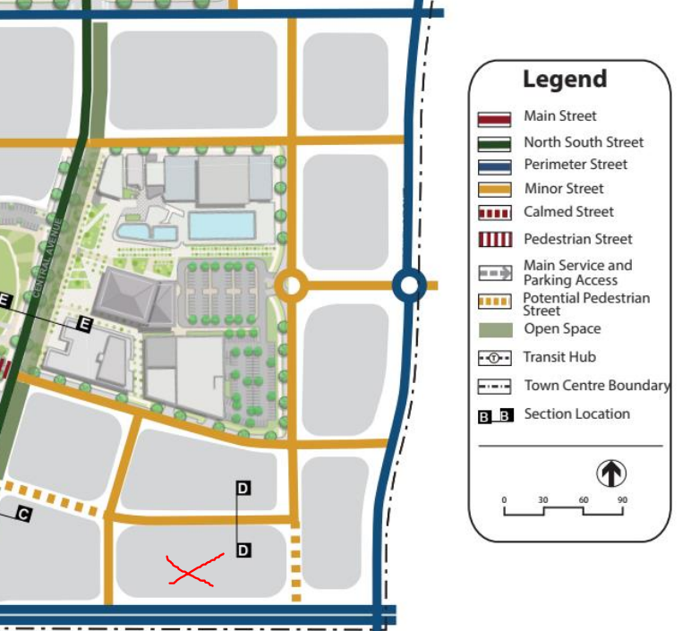 |  | The eastern most ‘potential pedestrian street’ shown by the red outline in the extracted figure 59 (see left) will be delivered as part of this proposal. The proposed eastern private road is consistent with figure 59 in that:  - Pedestrian only access is provided from the northern internal road to the southern road (Peter Brock Drive).  - The road supports vehicular movements however, is managed and maintained under a community title scheme. The road is embellished at a higher standard than a typical road. A variety of high-quality pavements, edgings, bollards and street tree blisters are provided as a means of creating a pedestrian friendly environment.  - The northern and western internal road identified by figure 59 are provided (and approved) by DA/2023/631/1. A condition of consent is recommended that requires these roads to be constructed and dedicated prior to issuing of any Occupation Certificate under this DA. |  | Yes.
(2) Traffic management measures are to be utilized within and surrounding the Town Centre to produce a low speed pedestrian friendly traffic environment, particularly within the Retail, Perich Park and Civic Precincts. Such traffic management devices are to be identified at the time of DA submission. |  | A series of street tree blisters creates pinch points along the eastern private road, which serve as a traffic calming device. |  | Yes.
4.2
Pedestrian and Cycle Movement.
(1) The Town Centre is to be designed to provide clear and legible pedestrian and cycle connections as identified in Figure 60.  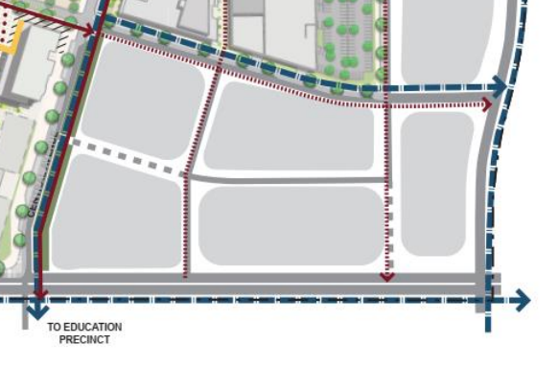 |  | The proposed development is generally in accordance with figure 60. This has been discussed in detail above under section 4.1 (control 1) in that pedestrian only access is provided from Peter Brock Drive to the northern internal road. |  | Yes.
(2) Streets and pathway networks should be designed to ensure that walking and cycling within the Town Centre takes priority over traffic circulation. |  | The eastern private road and centralized pedestrian through link are proposed to be embellished at a higher standard than a typical road. A variety of high-quality pavements, edgings, bollards and street tree blisters are provided as a means of giving priority to pedestrians. |  | Yes.
(3) Continuous weather protection for pedestrians is to be provided in key locations by colonnades or awnings |  | Weather protection is provided around the perimeter of Commercial Buildings 3 and 4 through a recessed ground floor and the use of awnings which connect between the buildings. |  | Yes.
(4) Bike parking facilities should be provided at key locations on streets within the Town Centre. No dedicated bike path is required along Main Street |  | Bike storage has been proposed within Commercial Building 4 accessible from the anticipated main entrance being the northern elevation. |  | Yes.
4.3
Road Types.
(1) Streets are to be provided generally in accordance with the cross-sections in Figure 61 to Figure 65. The dimensions shown on these typical diagrams are guidelines.  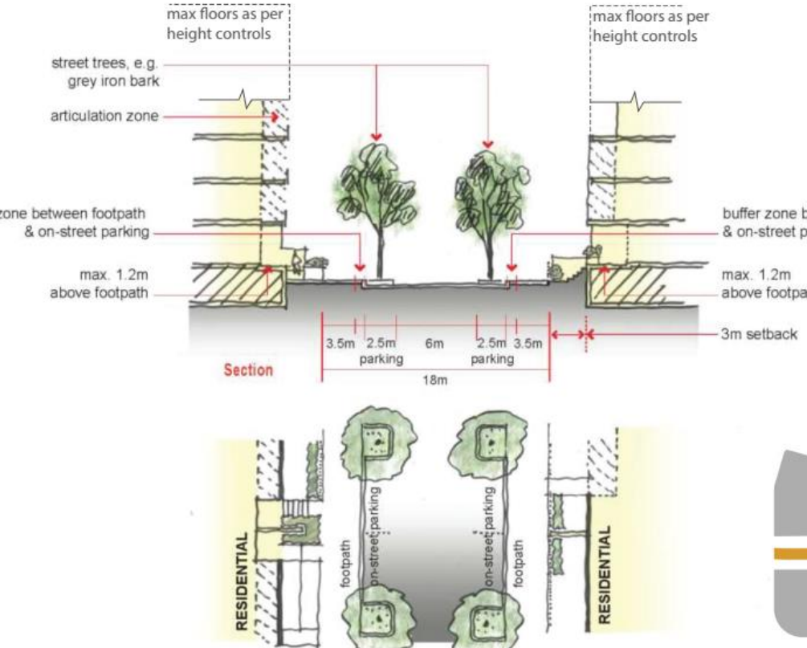. |  | The private road has been designed generally in accordance with section D in that it provides:  - 2.5m landscaped bays (no parking).  - 7.4m carriageway.  - 18m total width.  The private road is not consistent with figure D in that:  - The required 3.5m ‘buffer zone between footpath and on-street parking’ is provided at a reduced width of 3.0m.  - Residential development is required to provide a 3.0m setback to the inner edge of the ‘buffer zone between footpath and on-street parking’. The development is not a residential development and has provided a 2.11m setback from the first floor to the ‘buffer zone between footpath and on-street parking’.  Council staff are supportive of the minor deviation to figure D in that:  - The reduced 0.5m buffer zone is accounted for in that there is no parking proposed.  - The reduced 0.5m buffer zone enables a greater width to be provided to the carriageway in order to accommodate the occasional medium sized vehicle.  - The 3.0m setback required for the ‘buffer zone between footpath and on-street parking’ should not apply to the proposed development as it is not a residential development.  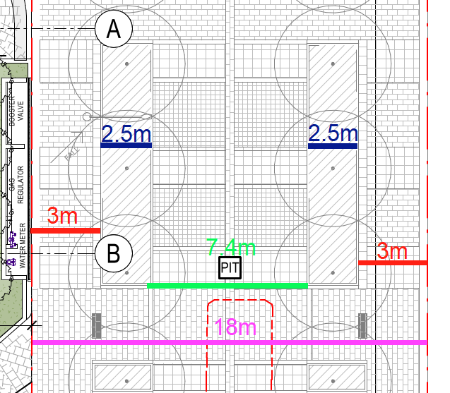 |  | No.
4.4
Public Transport.
(4) Bus stops are to be provided generally in accordance with Figure 66. |  | There is no bus stop shown by figure 66 that would need to be delivered by the proposed development. |  | NA
5.0
Public Domain, Water Sensitive Urban Design and Landscaping.
(1) Public domain areas are to be designed and located generally in accordance with Figure 67. The design of public domain areas shall take into consideration the Public Domain Manual adopted by Camden Council (Attachment A). |  | The private road adopts public domain paving observed throughout the town centre with the exception to P7 – Dover Grey Granite Paving. This paving is to be utlised as a means of signifying a shared zone across the private road which is consistent with the vision of this road being a pedestrian street. It is also acknowledged that this road will be managed and maintained under a community title scheme which would benefit the higher maintenance costs associated with the higher level of embellishment observed across this road. |  | Yes.
(6) All paving materials must conform to relevant standards for durability, non-slip textures, strength and surface treatment to withstand use by light automobiles, service vehicles, pedestrians and bicycles. |  | The paving materials have been provided in accordance with the public domain manual which conform to the relevant standards. |  | Yes.
5.2
Water Sensitive Urban Design Requirements
(1) All development shall generally be in accordance with the Oran Park Precinct Water Cycle Management Strategy and Master Plan prepared by Brown Consulting and adopted by Camden Council. |  | The proposed development has been provided generally in accordance with the strategy and masterplan and has been reviewed to the satisfaction of Council’s Engineering Certification team. |  | Yes.
5.3
Street Trees
(1) Development Applications, other than minor applications (e.g. shop fit-out, signage or change of use applications) shall include a landscaping plan prepared by a suitably qualified consultant. |  | The development application is accompanied with a landscape plan that has been prepared by a suitably qualified consultant. |  | Yes.
(3) Street trees and open space planting is to provide generous shade for pedestrians in summer and allow for sunlight penetration to street level in winter |  | Generous shading is provided through large canopy trees particularly concentrated with northern aspects. |  | Yes.
6.0
Environmentally Sustainable Development Principles.
(1) All new retail, commercial and mixed use buildings must achieve a minimum 4 star Green Star rating from the Green Council of Australia. |  | The sustainability initiatives strategy report indicates that the proposed development is capable of achieving a minimum 4-star green rating. To ensure the controls as set out in attachment B of the Oran Park DCP are achieved, an appropriate condition is recommended. |  | Yes.
7.1
Built Form Articulation.
(1) Articulation zones should be provided to compliment the building mass and emphaise key design elements such as entrance points and respond to environmental conditions including solar access, noise, privacy and views. |  | A large open space area is provided between the two commercial buildings and near to main building entrances. The massing of the building is responsive to its respective frontages announcing at corners and recessing the development along larger spanning frontages such as the internal northern road. |  | Yes.
7.2
Architectural Character.
(1) Articulation and Corners: Buildings at Oran Park Town Centre are to generally align with street edges, be articulated in their façade treatments and express corners in design. |  | The buildings respond to street edges adopting a recessed ground floor, curved edges and the use of cladding of varied materials and colours, rendered concrete and sun shades. The buildings are well articulated in their design and incorporate a range of treatments which express corners in their design. |  | Yes.
(2) Corners are to be visually prominent and may be reinforced by one and two storey verandas / balconies which turn the corner in a traditional manner. |  | Massing is concentrated to each corner as a means of announcing visual prominence. |  | Yes.
(3) Building Interface: The interface between the building and the public domain is to be designed to create active safer streets, to encourage flexibility in design for changing uses at ground level and provide weather protection for pedestrian amenity. Residential apartments above Town Centre streets will provide opportunities for casual surveillance. |  | A variety of measures are incorporated by the proposed development to increase activation and safety to the public domain. The ground floor is setback beneath the floors above creating weather protection around the perimeter of the buildings and increasing public / private domain. The proposed development seeks to provide large paved and turfed areas embellished with seating, tables and shaded areas. The strategies employed enable a gradual transition from the public domain to the private domain. |  | Yes.
(5) Building facades are to be designed to accentuate key architectural features and clearly delineate points of interest such as building entries, vertical and horizontal elements. |  | Wayfinding around the development is accentuated through architectural features which draws to the corners and via the centralized pedestrian through link. |  | Yes.
(6) Building facades are to incorporate a variety of finishes and materials which provide visual relief to the built form. |  | A variety of materials, colours and finishes are provided, these include:  - Cladding.  - Glazed and non-glazed glass.  - Metal and glazed louvres  - Perforated panels.  - Off-form concrete.  - Vertical solar shading devices.  - Horizontal sun shading shelfs.  The materials, colours and finishes assist in reducing the overall bulk and scale of the building providing interest and visual relief. |  | Yes.
(7) A diverse palette of durable and cost efficient external materials exploring a contemporary urban character whilst representing themes of Australian local character should be used. A range of materials is to introduce a fine grain façade treatment along street edges. |  | This has been discussed in the above control. |  | Yes.
7.3
Building Envelopes / Bulk and Scale.
(1) Building heights are to be in accordance with the Building Envelope Plan shown in Figure 69.  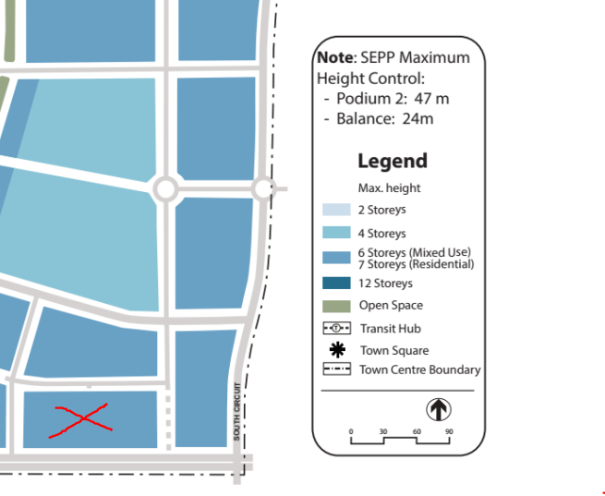 |  | Commercial Buildings 3 and 4 are a maximum of six storeys in height as envisaged by figure 69. |  | Yes.
(2) Prominent street corners should be reinforced in a visual context through concentrating building height and built form |  | The buildings respond to street edges adopting recessed ground floors, curved edges and the use of cladding in varying material colours, rendered concrete and sun shades. The buildings are well articulated in their design and incorporate a range of treatments which celebrate the prominence of corners visible from Peter Brock Drive. |  | Yes.
(3) Buildings are to be designed to ensure a human scale is maintained at street level |  | Human scale is maintained through an increased ground floor setback around the perimeter of the buildings. Additional landscaping, seating areas and breakout spaces within the public domain assist in creating a human scale environment around the buildings. |  | Yes.
(4) Minimum ceiling heights are detailed in in the table below. For the purposes of this control ‘ceiling height’ is measured internally from finished floor level to ceiling level. See Figure 70.  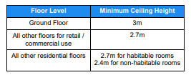  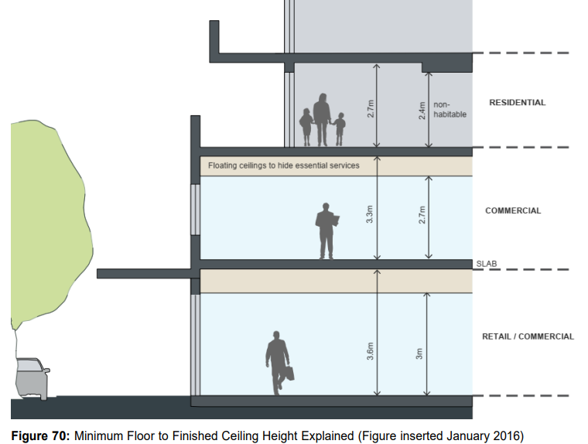 |  | Both buildings provide a 5.1m high ceiling at the ground floor, 3.8m to the 2nd floor and 3.65m from the 3rd floors to the 6th floors. The proposed buildings comply with figure 70. |  | Yes.
7.4
Quality of Indoor Environment.
(1) Refer to indoor environment controls provided in Attachment B. These controls are required to be assessed as part of the Sustainability Assessment. |  | The proposal is accompanied with a sustainability report and a Section J report. A condition of consent is recommended to ensure ongoing compliance with attachment B. |  | Yes.
7.5
Weather Protection.
(1) Weather protection must maintain a feeling of openness and enhance both the public function of the specific space and / or street. |  | Weather protection is provided to the internal perimeter footpaths by way of a varying 1.6m – 4.0m building overhang around all elevations of both buildings. Additionally, there is an awning which connects between the two commercial buildings that creates weather protection to those travelling between the two buildings. |  | Yes.
(2) Weather protection devices shall take into account wind, sun, rain, night / day, seasons and shadowing effects of other built components. |  | Increased weather protection has been provided to the northern aspects where greater weather protection is provided by the overhanging first floor. Additional attention has been given to providing increased canopy trees to the central communal outdoor area. |  | Yes.
(3) Weather protection devices shall consider the scale of adjacent buildings and the width of the street / public space in order to ensure appropriate proportions and “feel” |  | Deeper weather protection provided to the north-eastern, northern and north-western elevations with reduced protection provided to the southern facing elevations. The building itself will provide adequate shade and protection from rain to the southern facing elevations. |  | Yes.
(4) Weather protection solutions shall be predominantly naturally ventilated. |  | Weather protection is provided around the perimeter of Commercial Buildings 3 and 4 through a recessed ground floor. In addition, the use of an awning which connect between the buildings has been incorporated to the design. The weather protection provided is naturally ventilated. |  | Yes.
(5) Weather protection should be included as part of the design of the architecture / built form or landscape design. |  | Weather protection is provided as described above and shown on the approved plans. |  | Yes.
(6) The design of the weather protection shall take into consideration ESD objectives. |  | ESD objectives have been incorporated through the design. |  | Yes.
(7) Pedestrian rights of way, plazas and other public spaces will typically have a variety of weather protection devices, where provided, ranging from minimal protection, fixed or temporary devices (including an array of devices such as awnings, canopies, “floating” roofs or be incorporated into the architecture of the building), and landscaped solutions, thus providing a variety of experiences and conditions. |  | Weather protection is provided around the perimeter of Commercial Buildings 3 and 4 through a recessed ground floor and the use of awnings which connect between the buildings. |  | Yes.
(9) Awnings increase the usability and amenity of public footpaths by protecting pedestrians from sun and rain. Awnings encourage pedestrian activity along streets and, in conjunction with active edges such as retail frontages, support and enhance the vitality of the Town Centre. Awnings can be used in conjunction with colonnades. There are to be no wing walls so colonnade is continuous and unimpeded.
(10) Street level awnings should be provided to all retail frontages and commercial entries and to main lobbies of residential buildings except where a colonnade is required.
(11) In particular, continuous awnings and colonnades are required to be provided along the ground floor street frontage on active street frontages in accordance with Figure 71.
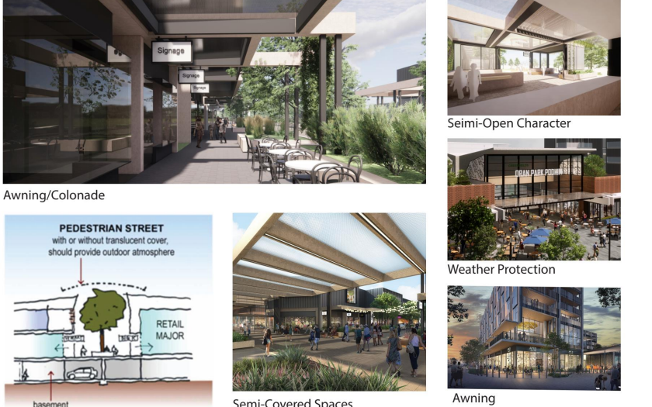
7.6
Setbacks.
(1) Building setbacks are to be provided in accordance with the Setbacks Plan shown in Figure 72.  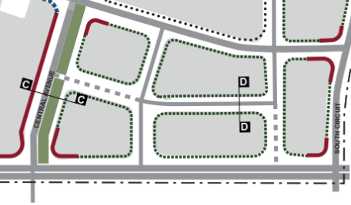 |  | Setbacks are as follows:  Commercial Building 3:  - Northern setback = 1.65m to 4.6m.  - Eastern setback = 14.9m to 19.4m (between buildings).  - Southern setback = 2.7m to 4.4m.  - Western setback = 1.9m to 3.0m.  Commercial Building 4:  - Northern setback = 2.2m to 4.2m.  - Eastern setback = 2.5m to 8.7m.  - Southern setback = 3m to 4.4m.  - Western setback = 14.9m to 19.4m (between buildings).  Note: setback of 3.0m applying to the site is for residential development only. The proposed development is not subject to a specific numerical setback control. |  | Yes.
(2) The urban character is achieved by adopting “build–to” lines or zero setback conditions to create street walls and by variety in “build–to” conditions for different types of streets. The main building facades are to be built to the block edge with allowances for insets and projections and to create stronger corner edges. |  | The proposed development adopts a recessing and projecting first floor. The façades are at their closest point to the boundary line toward the corners of the proposed development.
(3) Projections beyond the “build–to” lines could include awnings, verandas, balconies, roof overhangs 214 Oran Park Development Control Plan – Amendment No.12 and blade walls |  | The site is not subject to build to lines. |  | NA.
(4) Setbacks for residential buildings to be a minimum of three metres to allow for ground level front courtyards or private open space, changes in levels etc. Selected corners to residential sites may be required to “build–to” the street boundary. |  | The development is not a residential building. |  | NA.
7.7
Streetscape Activation.
Active frontage uses are defined as one of a combination of the following at street level  entrance to retail.  - Shop front.  - Glazed entries to commercial and residential lobbies occupying less than 50% of the street frontage, to a maximum of 12m frontage.  - Café or restaurant if accompanied by an entry from the street.  - Active office uses, such as reception, if visible from the street.  - Public building if accompanied by an entry. |  | The development has incorporated:  - Clear glazed entry to Commercial Building 3 fronting the west 6.4m in width and glazed entry to Commercial Building 4 fronting the east 6.4m in width.  - Office areas on the ground floor will be visible from all road frontages.  Future proposals at the ground floor involving fit-out works will have the capability to provide active frontages created through the building design. |  | Yes.
(2) Buildings are to maximise areas of street activation through a mixture of ground floor retail / commercial suites and the incorporation of ground floor terrace areas along the street frontage in residential development |  | Ground floor commercial suites are proposed to all street frontages and the north / south pedestrian through link between the two buildings. Overall, these arrangements will encourage activation. |  | Yes.
(3) Active street fronts, built to the street alignment, are required on the ground level of all retail and commercial development. |  | The proposed development is not identified by figure 72 as requiring a build to boundary. The increased ground floor setbacks proposed have enabled a high quality, activated public domain to be provided. |  | Yes.
(5) Ground floor residential uses (other than entries to lobbies to residential uses above ground level) are not permitted on the Town Centre Main Street. |  | The development is not a residential building. |  | NA.
(6) Restaurants, cafes and the like are to consider providing openable shop fronts. |  | Development is not for retail premises. |  | NA.
(7) No external security shutters to be permitted. |  | No external security shutters are proposed. |  | Yes.
(8) On corner sites, shop fronts are to wrap around the corner. |  | Development is not for retail premises. |  | NA.
7.8
Solar Access.
(1) Any Development Application for the construction of buildings is required to submit detailed solar access diagrams for between 9am and 3pm mid-winter to demonstrate sufficient solar access is maintained to public and private spaces and streets. |  | Shadow diagrams have been provided. The site is bound by Peter Brock Drive to the south which will predominately be overshadowed as a result of the proposed development. The development is also bound by two local roads and a private road north, west and east of the development. Those streets are not envisaged as containing any significant space or place that would otherwise be compromised by the proposed overshadowing. As such, the proposed development does not significantly reduce solar access to public or private spaces and places. |  | Yes.
(2) Parks and plazas are to receive sunlight on a minimal of 50% of their site area between 11am and 2pm on June 21. |  | The proposed development provides a small embellished open space area located centrally between the two buildings. This area has an optimal northerly orientation. It receives direct solar access from 10am to 2pm to at least 50% of its area (approx. 1,199m²) on June 21. |  | Yes.
(3) Building envelopes are to allow for north-south streets to receive 2 hours of sunlight between 9am-3pm on 21 June on a minimum of 50% of the eastern or western footpaths. |  | The eastern footpath will receive 3 hours of sunlight between 9am – 12pm to the entire footpath. The western footpath will receive 2 hours of sunlight between 12pm – 2pm. |  | Yes.
(4) Building envelopes are to allow for east-west streets to receive 1 hour of sunlight between 9am-3pm on 21 June on a minimum of 50% of the southern footpaths. |  | The site is envisaged to accommodate a six storey building. Achieving one hour of sunlight between 9am to 3pm on June 21 to a minimum of 50% of the southern footpaths (Peter Brock Drive) is not achievable. |  | No.
8.1
Vehicle Parking and Storage.
(1) Retail facilities are to provide parking at the rate of one (1) space per 30m². Larger retail uses would be subject to the RTA Guide for Traffic Generating Developments. |  | No retail facilities have been proposed. Car parking has been assessed under section 2.18 of the Camden DCP and complies in full. |  | Yes.
(2) Car parking dimensions are to be provided in accordance with relevant Australian Standards |  | Parking provided is in accordance with the relevant Australian Standard and has been reviewed by Council’s Engineering Certification team who support the proposed development (subject to recommended conditions). |  | Yes.
(3) On street parking to be provided throughout the Town Centre to contribute to street life and surveillance. |  | No public roads are proposed. |  | NA.
(4) Above ground parking is not encouraged without appropriate design measures to mitigate adverse visual impacts. |  | No above ground parking proposed. |  | NA.
(5) Below ground car parking is encouraged for higher density residential and mixed-use blocks as well as Town Centre retail blocks. |  | Below ground (three levels of basement parking) is proposed. |  | Yes.
(6) Where below ground parking is along a street edge and cross ventilation is desirable, any exposed section of car park wall is to be appropriately modelled and scaled |  | There is no exposed section of car park wall. The development proposes a mechanical exhaust riser which has been architecturally screened. |  | Yes.
(7) The majority of car parking is to be provided under Town Centre buildings and on street to limit visual impact and maintain pedestrian amenity. |  | Only below ground parking (three levels of basement parking) is proposed. |  | Yes.
(8) Natural ventilation of basement and sub-basement parking areas is encouraged to be provided wherever possible. |  | The development proposes a mechanical exhaust riser which has been architecturally screened. |  | Yes.
(9) Service vehicle access points should be consolidated where possible to limit the potential for conflict points. |  | The service vehicle access point has been consolidated to one shared point accessible via the eastern private road. |  | Yes.
(10) Bicycle racks / storage areas are to be provided in all developments in accordance with the following requirements. Bicycle racks / storage areas should be provided for both residents / employees and site visitors:  − non-residential development = 1 space per 750m2 of gross leasable floor |  | Total leasable area floor area:  Commercial Building 3 = 11,087sqm  Commercial Building 4 = 11,065sqm  Bike storage provided within Commercial Building 4.  Total spaces generated = 30, total provided = 39. |  | Yes.
8.2
Loading Docks.
(1) Loading docks are to be developed in accordance with the standards provided in Council’s comprehensive DCP |  | Considered further under section 2.18 from the Camden DCP assessment attachment. |  | Yes.
8.3
Roof Top Carparking.
(1) Roof top car parking can provide additional parking opportunities within the Town Centre if provided should give direct access to upper level commercial and retail premises. |  | No rooftop parking is proposed. |  | NA.

